**Project Description**

The **Mentor Dashboard Power BI Project** is designed to provide a comprehensive and interactive view of mentorship-related data, enabling better tracking, analysis, and decision-making. This dashboard consolidates multiple datasets into a single, visually appealing report that helps mentors, administrators, and academic coordinators quickly assess the status and performance of mentorship programs.

The dashboard consists of one primary page that combines various visualizations, including **KPI cards, tables, and charts**, to present data in a clear and actionable format. KPI cards provide instant insights into key numbers such as the total number of mentors, mentees, and engagement statistics. Tables are used to display detailed mentor information and mentee lists, allowing users to easily access granular data when needed. Additionally, charts such as bar graphs and pie charts visualize the distribution of mentees across mentors, departments, or other relevant categories, making it easier to identify patterns, gaps, or imbalances.

Branding elements such as a **custom logo and themed background** have been integrated into the report, enhancing its professional appearance and making it easy to align with institutional identity. The interactive nature of the dashboard allows users to apply filters and drill through data, enabling deeper exploration of specific mentors, departments, or engagement trends.

This project ultimately serves as a **decision-support tool**, helping stakeholders monitor the effectiveness of mentorship programs, improve resource allocation, and identify areas that require attention. By presenting data in an organized, intuitive, and visually engaging format, the Mentor Dashboard promotes data-driven decision-making and contributes to the overall improvement of mentorship quality and student support systems.

**Objectives**

1. To Consolidate Mentor–Mentee Data in a Single Platform.
2. To Provide Actionable Insights Through Interactive Visualizations.
3. To Improve Monitoring and Engagement in Mentorship Programs.

**Data Set 1 – Sheet1 (Personal & Academic Details)**

* **Name** – Stores the name of the student (e.g., Vasireddy Sanjana).
* **10th (Marks)** – Records the marks or percentage scored in 10th standard examinations.
* **12th (Marks)** – Records the marks or percentage scored in 12th standard examinations.
* **Branch** – Indicates the academic branch or department the student belongs to.
* **Category** – Specifies the category of the student (General, OBC, SC, etc.).
* **Data of Birth** – Holds the student’s date of birth for identification.
* **Blood Group** – Captures the student’s blood group information.
* **Duration of … (likely Course Duration)** – Represents the total duration of the student’s academic program.
* **Father Name** – Contains the father’s name for record-keeping.
* **Hobby** – Mentions the student’s personal hobbies for mentor reference

**Data Set 2 – Sheet2 (Academic Performance & Attendance)**

* **Name of the Subject** – Lists all subjects taken by the student (e.g., Statistics, Marketing, HRM).
* **Attendance %** – Shows the student’s attendance percentage in each subject.
* **Absent %** – Displays the percentage of classes missed by the student in each subject.
* **Grade** – Provides the grade achieved by the student (A, B, C, E, etc.).
* **Semester** – Indicates the semester to which the subject belongs.

**LINK**

<https://drive.google.com/file/d/1duqTzAXfY2GkFKTcSbXIX_8O9gnI1CwR/view?usp=sharing>

**PICTURE**

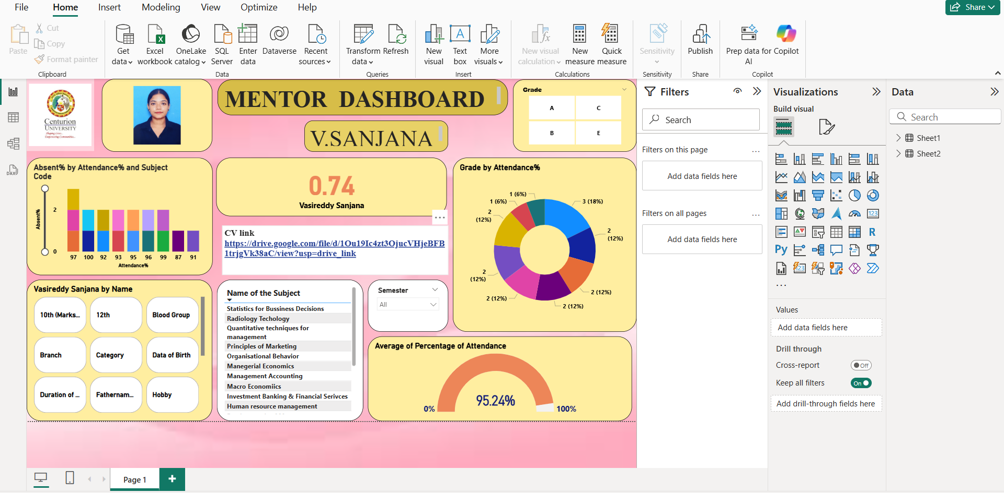

**1.Title & Profile Section:**

* Mentor Dashboard – Title of the report.
* Student Name & Photo – Displays the selected student (V. Sanjana) for quick identification.
* University Logo – Branding for Centurion University, making it look official and professional.

**2.Bar Chart – Absent % by Attendance % and Subject Code:**

* Shows how many classes were missed in each subject based on attendance percentage.
* Helps mentors identify which subject has the highest absenteeism rate.
* Example: If one subject has very low attendance %, it is easy to focus on that subject specifically.

3.**Card Visual – 0.74 (Key Metric):**

* This represents a calculated KPI like absenteeism ratio or performance score.
* Displays it in a big, bold number for quick monitoring.

4.**CV Link:**

* Provides a clickable link to the student’s CV stored in Google Drive.
* Helps mentors view the student’s professional profile directly.

5.**Student Details Card (Left Side):**

* 10th Marks, 12th Marks – Academic history
* Branch & Category – Program and category information
* Date of Birth & Blood Group – Personal details
* Duration of Course, Father’s Name, Hobby – Extra details for mentor reference

6.**Subject List Table:**

* Lists all subjects enrolled by the student (Statistics, Radiology, Marketing, HR, etc.).
* Useful for viewing semester-wise subject load.

7.**Semester Slicer:**

* Allows mentors to filter dashboard data by specific semester.
* Clicking a semester will refresh all charts and tables.

**8.Donut Chart – Grade by Attendance %**

* Shows how grades are distributed based on attendance levels.
* Helps identify the correlation between attendance and academic performance.
* Example: Students with high attendance usually have higher grades.

**9.Gauge Chart – Average Attendance %**

* Displays the student’s overall average attendance percentage in a gauge format.
* 95.24% here means attendance is very good and above the required level.

**10.Slicer:**

* Grade filters (A, B, C, E) allow viewing students by grade category.
* This is useful when mentors want to check which students scored low (E grade) or high (A grade).

This dashboard serves as a single-page report of a mentor:

* It tracks student attendance & performance.
* Highlights problem areas (low attendance/low grades).
* Helps mentors take action by contacting students or giving feedback.
* Provides a professional touch with branding and CV integration.

**FLOW CHART**

Data Collection

Data Preparation & Cleaning

Data Import into Power BI

Data Modeling & Measure Creation

Dashboard Design & Visualization



Dashboard Formatting & Branding

Insights & Usage

Decision-Making & Action

**LAYOUT**

* **Project Title:** Mentor Dashboard using Power BI
* **Prepared By:** V. Sanjana
* **Registration Number**: 233209120005
* **Institution Name:** Centurion University of Technology and Management
* **Date of Submission:** 16-09-2025

**CONTENT:**

* Project Overview
* Objectives
* Dataset Explanation
* Link
* Picture explanation
* Flowchart / Storyline
* Layout
* Conclusion

**CONCLUSION**

The Mentor Dashboard provides a comprehensive and visually interactive way to monitor and evaluate student performance and attendance in a single view. By combining personal details, academic records, subject-wise attendance, and overall performance metrics, the dashboard allows mentors to identify problem areas quickly and take necessary action. The inclusion of interactive filters and slicers enables a detailed analysis of student progress across different semesters and grades, promoting data-driven decision-making. With visual elements like bar charts, donut charts, and gauge charts, the dashboard offers an intuitive and engaging interface that simplifies complex data interpretation. Overall, this project helps strengthen the mentor-student relationship by enabling timely guidance, improving attendance levels, and encouraging better academic outcomes.